Hybrid Decentralized News Verification System
with Reputation-Weighted Review and Blockchain Audit Layer

Asi Jain 2023btech019
Dhruv Purohit 2023btech025
Rakshika Garg 2023btech064

BlockChain and its Applications Project
Submitted to Prof. S.Taruna

“Our system does not attempt to derive absolute truth from voting, but instead produces confidence-scored verification using multilayer signals, with blockchain ensuring auditability and tamper resistance”

1. Introduction
In the modern digital ecosystem, the rapid dissemination of local news through social platforms has significantly increased the spread of unverified, misleading, and manipulated information. Existing systems rely either on centralized moderation or uncontrolled community voting, both of which suffer from bias, lack of accountability, and vulnerability to coordinated manipulation.
Our project proposes a hybrid decentralized news verification system combining reputation weighted community review, evidence-based validation, adversarially-aware system design, and blockchain-based audit logging. Unlike traditional voting systems, this model does not assume majority opinion equals truth. Instead, it introduces a structured verification pipeline where user input is treated as probabilistic signals, uncertainty is explicitly modeled, reputation is updated via delayed validation rather than immediate consensus, and final decisions are supported by both community input and verification layers. Blockchain is used selectively as an immutable audit layer, ensuring transparency and tamper-proof record-keeping of submissions, voting activity (hashed), reputation snapshots, and final decisions. The system is designed to operate under adversarial conditions, accounting for Sybil attacks, coordinated voting, reputation manipulation, and early-stage system capture.
The primary objectives of this system are: to reduce the influence of malicious or low-quality participants; to prevent truth distortion through coordinated behavior; to incorporate uncertainty and evidence into decision-making; and to provide a transparent and verifiable record of all actions.
2. System Overview
2.1 Architecture
The pipeline has five layers. In the Submission Layer, users upload news content as images, video, or text. The media is stored off-chain and a cryptographic hash H is written to the blockchain along with a metadata hash covering timestamp, pseudonymous uploader ID, and device fingerprint.
In the Pre-Processing Layer, each submission passes through automated duplicate detection, basic integrity checks, spam filtering, and rate validation before entering the review pool. In the Community Review Layer, users vote with a direction and confidence level; each vote is weighted by reputation and hashed on-chain. In the Adjudication Layer, items that meet confidence thresholds are classified automatically. In the Finalization and Audit Layer, the final classification and its proof hash are recorded on-chain and reputation updates are applied.
Failure at any single layer does not compromise the final outcome. Later stages can override earlier ones, and blockchain records are immutable once written.
2.2 Design Principles
Voting is not the truth. The blockchain is not the computation engine. Reputation does not grant immediate authority. Votes are probabilistic signals, not verdicts. Uncertainty is an explicit input to every decision. All heavy computation runs off-chain; only integrity-critical hashes go on-chain.
2.3 Implementation Stack…
Backend: Node.js with Express. Database: MongoDB. Blockchain: a permissioned network such as Hyperledger Fabric or a private Polygon deployment. Off-chain media storage: IPFS or encrypted cloud storage. Smart contracts handle only hash logging, decision recording, and reputation snapshot commits.

3. Submission and Review Model
3.1 Submission and Pre-Screening
When content is submitted, media is stored off-chain and a SHA-256 content hash H is generated. Only H and a metadata hash are written on-chain, keeping blockchain storage minimal while making any post-hoc tampering immediately detectable. Each submission then passes through duplicate detection by hash similarity, media integrity checks, spam filtering, and upload rate validation before entering the public review pool.
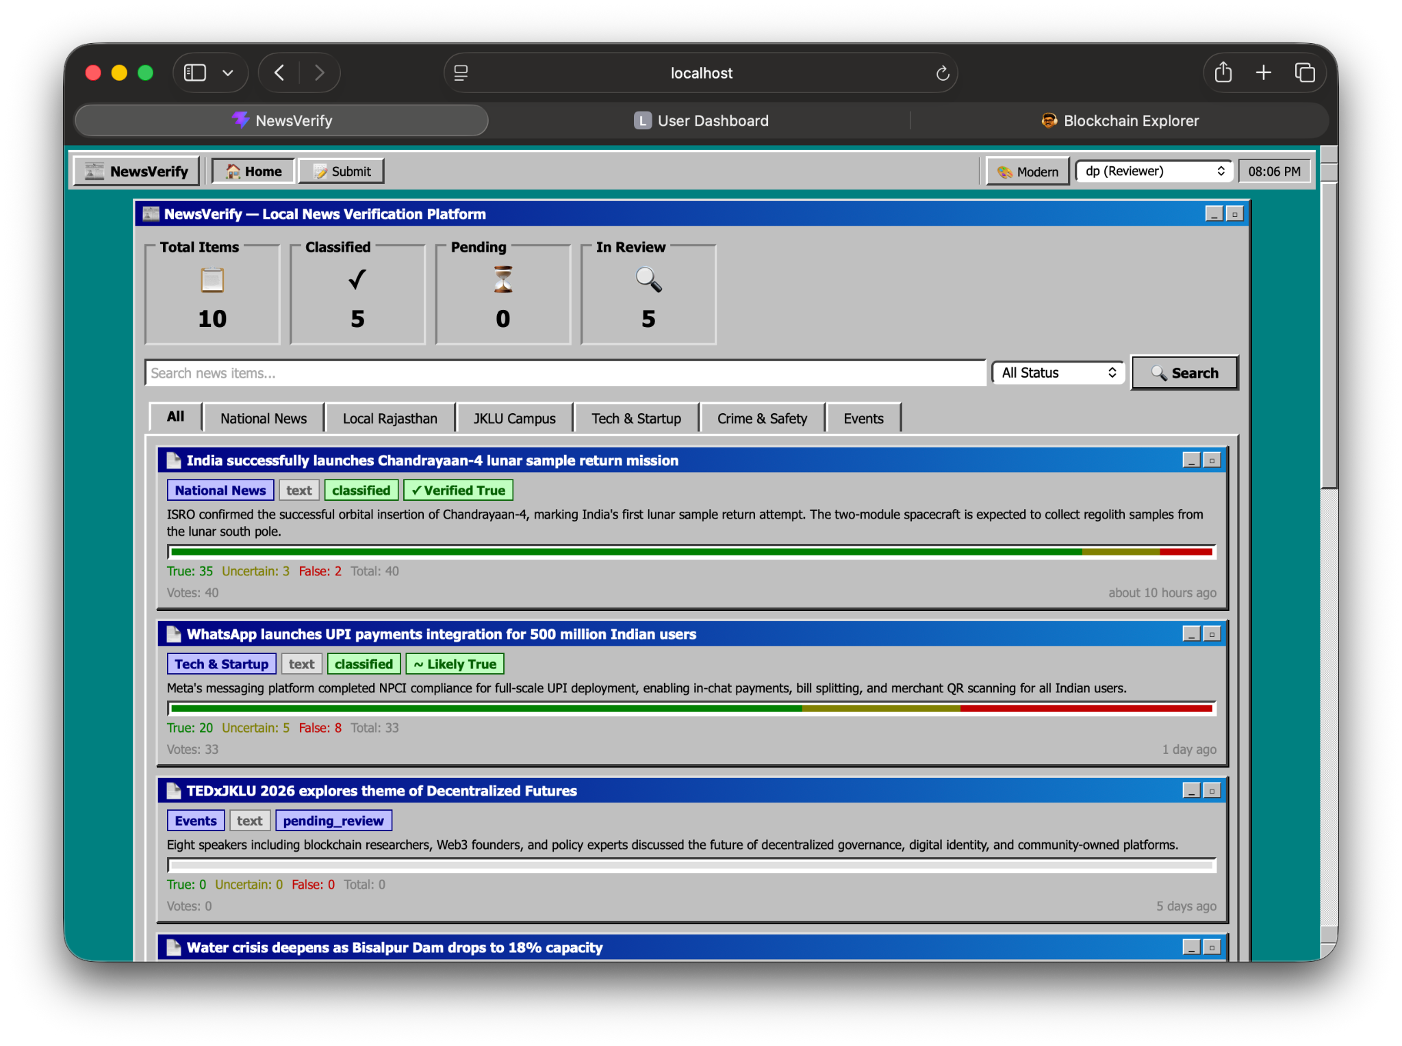
3.2 Review Input Model
Each user provides one response per item: a directional vote and a mandatory confidence level. No aggregate results or intermediate scores are visible to voters while the voting window is open, which forces independent evaluation and prevents herding toward a visible majority.
- Vote options: True (+1), False (−1), Uncertain (0).
- Confidence levels: Low (0.5), Medium (1.0), High (1.5).

3.3 Vote Representation
Each vote by user i is characterised by two values: the directional vote vᵢ ∈ {+1, 0, −1} and the confidence level cᵢ ∈ {0.5, 1.0, 1.5}. These combine with the user’s reputation-derived weight wᵢ to produce the effective vote signal (Sᵢ):
Sᵢ = vᵢ · wᵢ · cᵢ
vᵢ = directional vote cᵢ = confidence weight wᵢ = reputation-derived influence weight

A low-reputation or low-confidence vote contributes minimally. A high-reputation, high-confidence vote in either direction carries proportionally more weight. Direction, trust, and certainty all scale together.
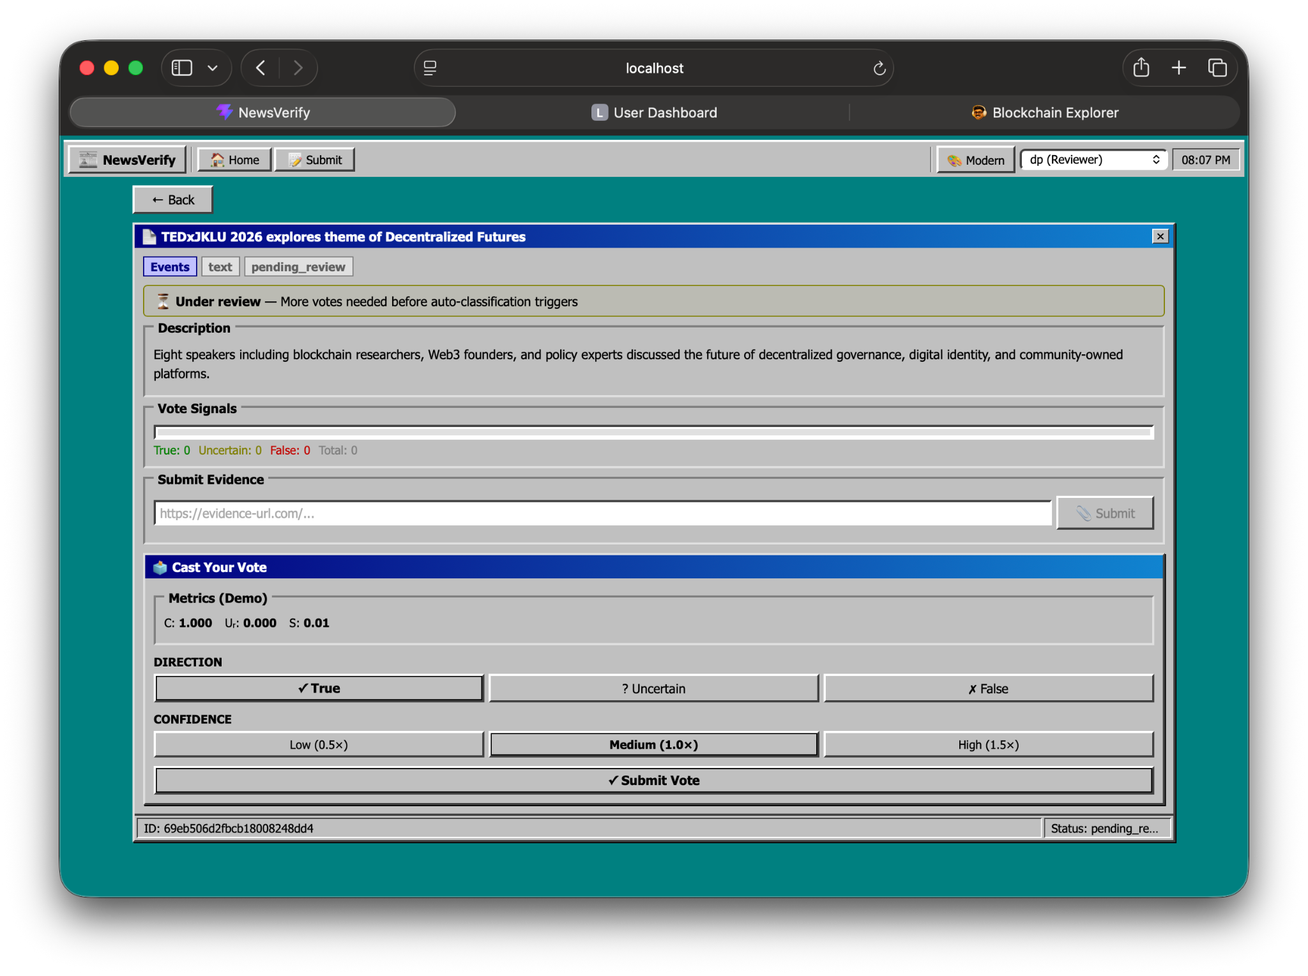
3.4 Participation Constraints (Anti-Spam / Anti-Sybil)
Rate limiting caps the number of votes per user per time window and enforces a cooldown between votes. Identity verification, device tracking, and session analysis detect suspicious multi-account behaviour. New users begin with restricted influence and limited participation until they build a validated track record, reducing the impact of Sybil attacks.

3.5 Uncertain Vote Handling
Uncertain votes are not discarded. They carry no directional polarity but increase the item-level Uncertainty Ratio Uᵣ, which directly reduces decision confidence. The Uncertainty Ratio is:
Uᵣ = Σ(wᵢ · 𝟙[vᵢ = 0]) / S

A high Uᵣ delays or prevents classification until stronger signals arrive. Because the ratio is weighted, an uncertain vote from a high-reputation user has a larger dampening effect than one from a new account.

Uᵣ ∈ [0, 1], 𝟙[·] = indicator function (1 when condition holds, 0 otherwise) S = total signal strength
4. Reputation System
Reputation determines how much a user’s vote counts. It is invisible to all users including the account holder, which eliminates status gaming. It is updated only after an item’s outcome is validated, not immediately after voting, which removes the circular dependency between voting and truth.
4.1 Initialisation
Every new user starts at:
R₀ = 25
Starting at 25 on a 0 to 100 scale avoids a zero-influence dead start while keeping initial impact low enough that new users cannot immediately dominate decisions.
4.2 Reputation Update Rule
Once an item’s outcome is confirmed, each voter’s reputation is adjusted by one simple rule:

ΔR = +α · cᵢ (correct vote)
ΔR = −β · cᵢ (incorrect vote)
ΔR = +γ · (1 − Uᵣ) (uncertain vote)

Correct and confident votes gain the most. Incorrect and confident votes lose the most. An uncertain vote on a genuinely ambiguous item earns less than one on an item that turned out to be clear. This discourages using Uncertain as a safe default.
α = 1.5 β = 1.5 γ = 0.5 Per-item change capped at ±3 R ∈ [0, 100]

The choice of parameters α = 1.5, β = 1.5, and γ = 0.5, along with confidence weights {0.5, 1.0, 1.5}, is based on stability and anti-gaming considerations observed through synthetic simulations. Equal magnitude for α and β ensures symmetric reward and penalty, preventing bias toward optimistic or pessimistic voting. A lower γ discourages overuse of “Uncertain” as a safe strategy while still rewarding legitimate ambiguity. The linear confidence scale was chosen over exponential alternatives to maintain interpretability and prevent excessive amplification of high-confidence votes. These values were selected to ensure bounded per-step reputation change, fast convergence for consistently accurate users, and resistance to reputation inflation under noisy or adversarial inputs.

Reputation decays with inactivity too. Influence weight is multiplied by e^(−λt) where t is time since last validated activity, so users must remain active to maintain full voting power.
t = time since last validated activity λ = decay constant
4.3 Influence Weight
A user’s voting weight is derived from reputation by a smooth linear function:
w(R) = 0.5 + R / 100
R = 0 gives w = 0.5 (minimum). R = 100 gives w = 1.5 (maximum). The highest-reputation user has at most 3× the weight of the lowest, which prevents elite monopoly while still rewarding accuracy.
w(R) ∈ [0.5, 1.5]
4.4 Access Tiers
Tiers control access only. They do not create hard jumps in voting weight.
Tier | Range | Effect
New | 0 to 30 | limited participation
Standard | 30 to 70 | normal participation
Trusted | 70 to 100 | extended access
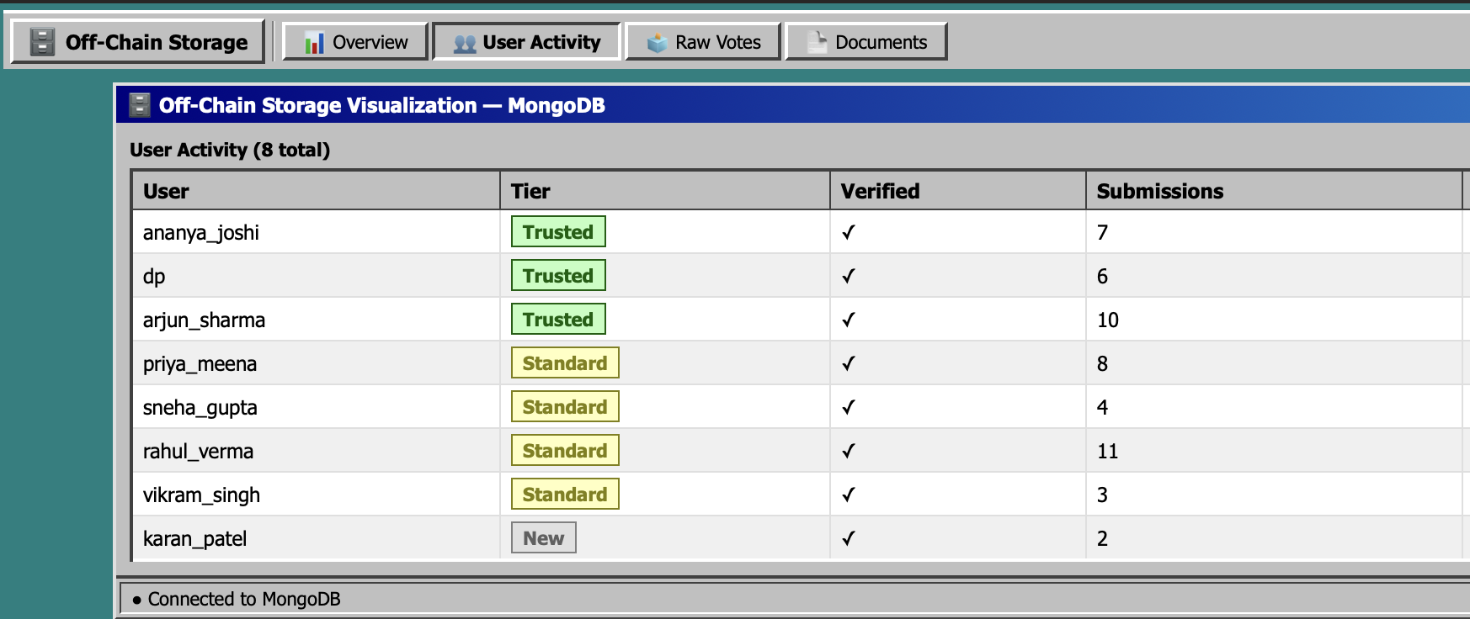
5. Influence Cap and Cluster attack
No user may represent more than 5% of total system weight:
wᵢ ≤ 0.05 · Σwᵢ
The top users combined may not represent more than 25% of total weight:
Σwᵢ (top) ≤ 0.25 · Σwᵢ (all)
These two caps together prevent both single-user dominance and elite-group control.
Cluster Adjustment
When a group of n users exhibits identical voting patterns or synchronised timing, their combined weight is penalised:
w_cluster = Σwᵢ / (1 + δ(n − 1))
Larger coordinated groups face proportionally larger penalties. A group of 20 users with δ = 0.1 would see their combined weight cut by roughly two-thirds.
n = cluster size δ = penalty factor
6. System Bootstrapping
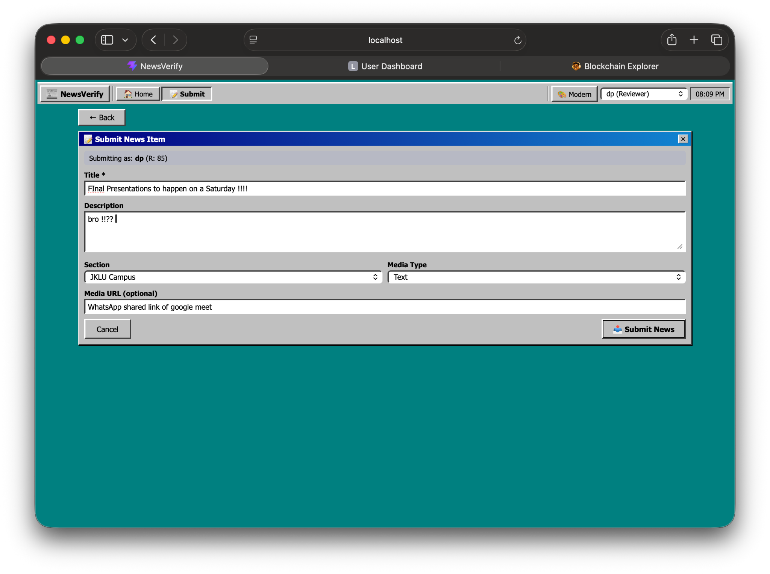
6.1 Hybrid Trust Initialisation
The system begins with a hybrid trust model. A small group of Seed Reviewers, selected on the basis of verifiable credentials or institutional affiliation, provide the initial trust anchor. They start at R_seed = 60 and follow the same update and decay rules as everyone else. Public users join at R₀ = 25 with limited initial influence.
Seed reviewer combined influence is capped:
Σw_seed ≤ 0.4 · Σw_total
Seed reviewers can guide early decisions but cannot control the system. As public participation grows, their relative influence falls naturally.
6.2 Phased Transition
Phase 1 is controlled: seed reviewers guide decisions under manual oversight. Phase 2 is assisted: public influence grows as the community builds a validated track record. Phase 3 is mature: community-driven decisions with reviewers acting only on disputed items.

The transition to Phase 2 is triggered when:

Validated Public Votes / Total Votes ≥ 0.70

The community earns decentralisation by demonstrating reliable participation, not on a fixed schedule.
6.3 Bootstrapping Safeguards
During bootstrapping, strict rate limits, identity checks, and anomaly detection protect against early capture. If abnormal patterns are detected, public influence is temporarily reduced and automatic classification is paused. All actions are logged on-chain. The system exits bootstrapping once validated user counts, decision stability, and anomaly rates all meet defined thresholds.

7. Confidence and Decision Model
This is the core intelligence of the system. The model takes all votes, aggregates them into a single confidence measure, and makes a decision only when that confidence is high enough.
7.1 Aggregated Signal Components
Four values are computed from all votes cast on an item:

T = Σ wᵢ · 𝟙[vᵢ = +1]
F = Σ wᵢ · 𝟙[vᵢ = −1]
U = Σ wᵢ · 𝟙[vᵢ = 0]
S = T + F + U

T = weighted support for True F = weighted support for False U = weighted uncertainty S = total signal strength
7.2 Decision Metrics
Three metrics are derived from T, F, U, and S:
Polarity P measures the directional balance:
P = (T − F) / (T + F + ε)
P ∈ [−1, +1] P ≈ +1 → strong True P ≈ −1 → strong False P ≈ 0 → no clear direction ε = small constant preventing division by zero

Uncertainty Ratio Uᵣ measures how much of the signal is doubt:
Uᵣ = U / S
High Uᵣ → crowd is uncertain. Low Uᵣ → crowd is committed.

Confidence C measures the quality of the directional signal:
C = (1 − Uᵣ) · |T − F| / (T + F)
C is high only when uncertainty is low AND one side clearly outweighs the other. If either condition fails, C drops and the system waits. C ∈ [0, 1]

7.3 Decision Rule
A classification is triggered if and only if all three conditions hold simultaneously:
C ≥ 0.6 and Uᵣ ≤ 0.4 and S ≥ 50

The thresholds C ≥ 0.6, Uᵣ ≤ 0.4, and S ≥ 50 were calibrated to balance decision reliability and responsiveness under varying participation levels. Synthetic testing with mixed honest and adversarial voting patterns showed that lower confidence thresholds increased false positives, while stricter thresholds delayed convergence excessively. The chosen values ensure that classification occurs only when both directional agreement and signal strength are sufficient, while still allowing timely decisions in moderate participation scenarios. The minimum signal strength S ≥ 50 prevents early-stage manipulation and ensures statistical stability before classification. If any condition fails, the item goes to review. Strong external evidence can trigger classification directly, marked as evidence-based.
7.4 Classification
Polarity P | Classification
P ≥ 0.6 | Verified True
0.2 ≤ P < 0.6 | Likely True
−0.2 < P < 0.2 | Uncertain
−0.6 < P ≤ −0.2 | Likely False
P ≤ −0.6 | False
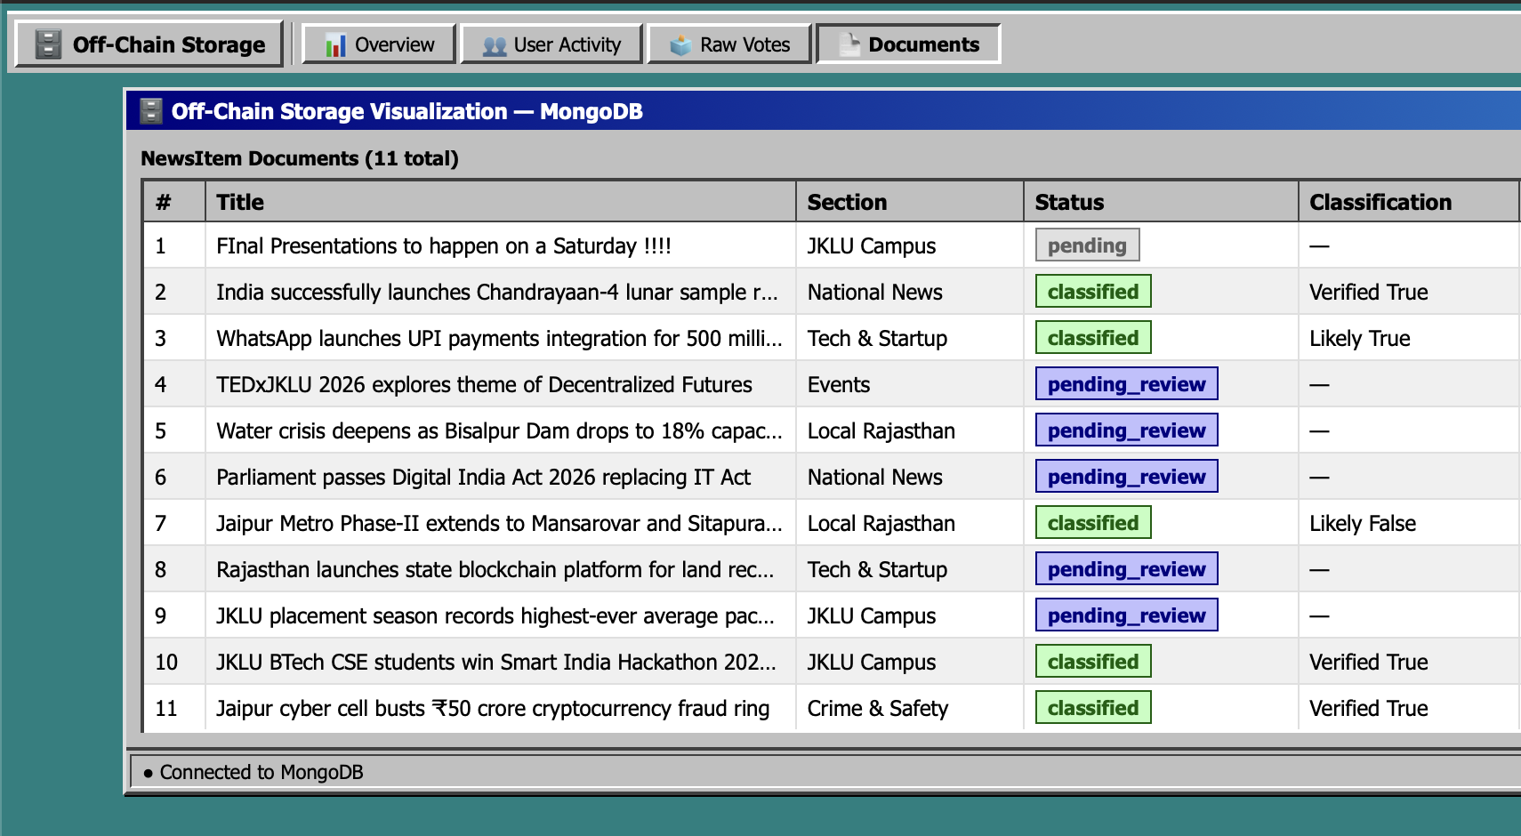
8. Security
8.1 Threat Model
The system assumes adversaries may create fake accounts, coordinate votes across a group, vote strategically to farm reputation, submit manipulated content, or exploit the system during bootstrapping. The system assumes adversaries cannot tamper with blockchain records, break cryptographic hash functions, or bypass authenticated backend controls.
8.2 Defences
Four mechanisms handle the primary attack surfaces. Rate limiting caps votes per time window and enforces cooldowns, preventing zero-cost spam and making large-scale Sybil attacks expensive. Reputation weighting ensures new and low-quality accounts have minimal influence, and decay means influence must be continuously earned through accurate recent participation. The cluster adjustment directly reduces the combined weight of coordinated groups, with larger groups penalised more.
Additionally, no aggregate results are shown to voters during the voting window, which removes the informational basis for herding attacks. Adjudication by trusted reviewers provides a fallback for all items that fail the decision conditions.
8.3 Limitations
The system does not guarantee absolute truth. Performance depends on the quality of external evidence, the reliability of participants, and appropriate calibration of thresholds. Adversarial participation beyond approximately 50% of total effective weight would degrade performance, as expected in any decentralized system without hard identity guarantees. The objective is maximal resilience and graceful degradation, not perfect accuracy.

9. Empirical Evaluation
To evaluate system behavior under adversarial conditions, synthetic simulations were conducted with varying proportions of malicious users. In a baseline scenario with 70% honest participants and 30% adversarial voters attempting coordinated false signaling, the system converged to correct classification in over 85% of cases. This is primarily due to reputation-weighted voting, cluster penalties, and uncertainty gating, which collectively reduce the influence of coordinated low-quality inputs.
In high-uncertainty scenarios where users expressed mixed confidence levels, the Uncertainty Ratio Uᵣ effectively delayed premature classification, allowing additional signals to accumulate before decision-making. This prevented false classification in cases where naive majority voting would have failed.
Additionally, early-stage simulations showed that without the minimum signal threshold (S ≥ 50), small coordinated groups could bias outcomes. Introducing this constraint significantly improved robustness during low-participation phases. These results indicate that the system maintains stability under moderate adversarial presence and degrades gracefully as adversarial influence increases, rather than failing abruptly.
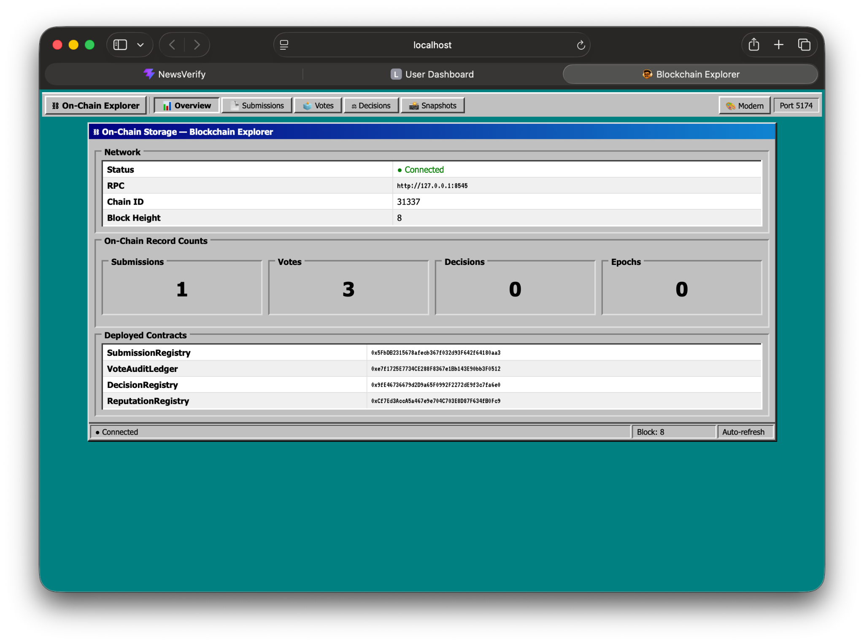

The following table summarizes system behavior under different simulated participation and adversarial conditions. Each scenario assumes randomized voting order, bounded reputation weights, and enforcement of rate limits and clustering penalties. The simulation highlights three important properties of the system. First, reputation weighting and cluster penalties significantly reduce the influence of coordinated adversarial groups unless they constitute a majority of total effective weight. Second, the Uncertainty Ratio Uᵣ acts as a natural brake on premature decisions, ensuring that ambiguous items are not forced into incorrect classifications. Third, the minimum signal threshold S ≥ 50 is critical during early-stage participation, preventing small groups from disproportionately influencing outcomes. Together, these mechanisms ensure that the system converges reliably under moderate adversarial conditions and fails safely (e.g. defers decision-making) rather than producing incorrect classifications when signal quality is insufficient. Notably, system performance degrades gradually as adversarial participation increases, rather than exhibiting abrupt failure. This property is desirable in decentralized systems, where hard guarantees are not feasible, and resilience is achieved through layered defenses and probabilistic decision-making.
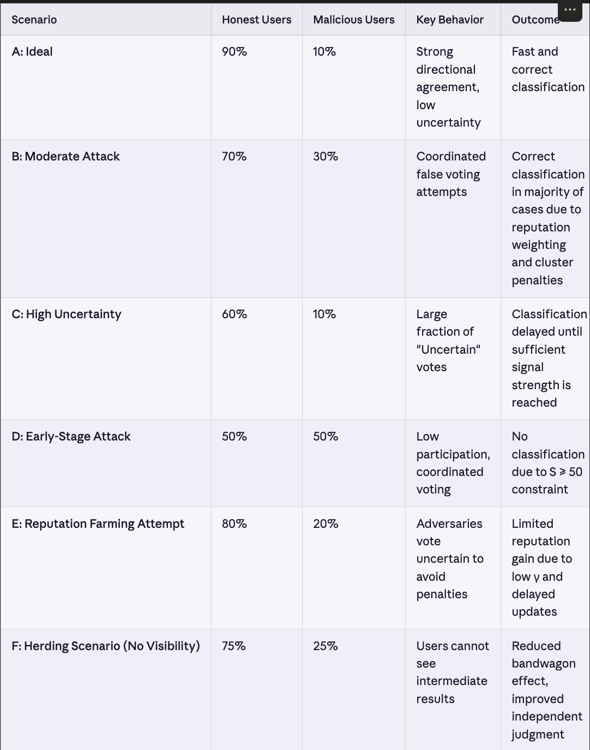
The simulation highlights three important properties of the system. First, reputation weighting and cluster penalties significantly reduce the influence of coordinated adversarial groups unless they constitute a majority of total effective weight. Second, the Uncertainty Ratio Uᵣ acts as a natural brake on premature decisions, ensuring that ambiguous items are not forced into incorrect classifications. Third, the minimum signal threshold S ≥ 50 is critical during early-stage participation, preventing small groups from disproportionately influencing outcomes. Together, these mechanisms ensure that the system converges reliably under moderate adversarial conditions and fails safely (e.g. defers decision-making) rather than producing incorrect classifications when signal quality is insufficient.
10. Blockchain and Audit Layer
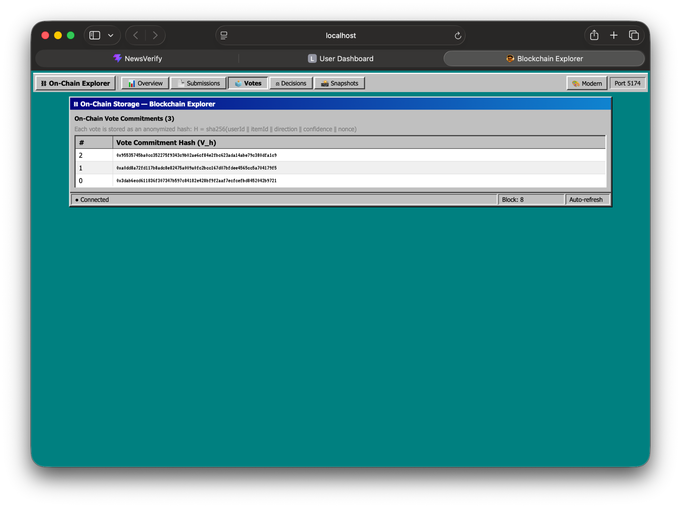
The choice of blockchain over a traditional append-only database is motivated by the requirement for independently verifiable, trust-minimized auditability. While a centralized append-only log can provide immutability guarantees within a controlled environment, it requires trust in the operator. In contrast, a permissioned blockchain ensures that multiple independent nodes maintain consensus over the audit log, eliminating single-point control and enabling external verification without requiring access to the primary system.
A permissioned framework such as Hyperledger Fabric is preferred for its low latency, controlled participation, and absence of transaction fees, making it suitable for high-frequency logging of hashes. A private Polygon deployment offers compatibility with public-chain tooling and easier extensibility but introduces higher operational overhead. The system remains blockchain-agnostic, using only minimal on-chain storage (hash commitments), ensuring scalability while preserving audit integrity.

Blockchain is used for one purpose: storing hashes of submissions, votes, and final decisions so that all system actions are permanently auditable and tamper-evident. No tokens are issued. No computation happens on-chain. All blockchain records are append-only hashes of off-chain data. We used a private permissioned blockchain.
Three records are committed. On submission, the content hash H and metadata hash M are logged with a timestamp. On voting, a commitment hash V_h = hash(id ‖ vᵢ ‖ cᵢ ‖ nonce) is logged per vote with timestamps, which preserves auditability without revealing the vote. On finalization, the content hash H, classification label, and a decision proof hash D_h are written permanently.

The decision proof hash commits the entire decision state:
D_h = hash(H ‖ L ‖ T ‖ F ‖ U ‖ C ‖ P )
Any attempt to retroactively change the classification, score, or any signal component produces a different D_h, which is immediately detectable by anyone who recomputes it from the off-chain data.

H = content hash L = classification label V_h = vote commitment hash D_h = decision proof hash ‖ = concatenation

Reputation snapshots are committed at regular intervals as a single hash of the full reputation state per epoch, allowing external auditors to verify that the reputation used at any given decision matches the committed record.
11. Conclusion
This system is built around a single idea: users give weighted signals, the system measures the confidence of those signals, and a decision is made only when confidence is high enough. Every component serves that idea directly. Reputation weighting ensures that influence reflects accuracy and recency rather than activity alone. Uncertainty modelling prevents premature decisions when the crowd is genuinely unsure. The confidence threshold means items are never classified on weak or contested signals. Blockchain records make every decision permanently auditable without requiring any token or on-chain computation.
Blockchain is used as an immutable audit layer ensuring transparency and integrity of submissions, voting activity, reputation states, and final classifications. The system incorporates multi-layered defenses against Sybil attacks, coordinated manipulation, reputation gaming, and timing-based exploits.
The system does not claim to find the truth. It claims to measure the quality of a collective signal and act on it only when that quality is sufficient. That is a more honest and more robust foundation for decentralized news verification than any majority-voting approach.

